**

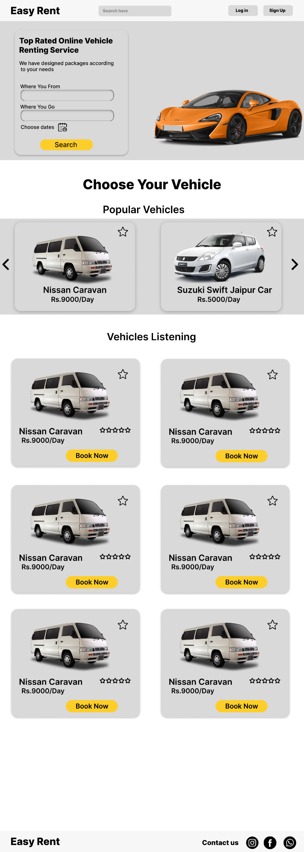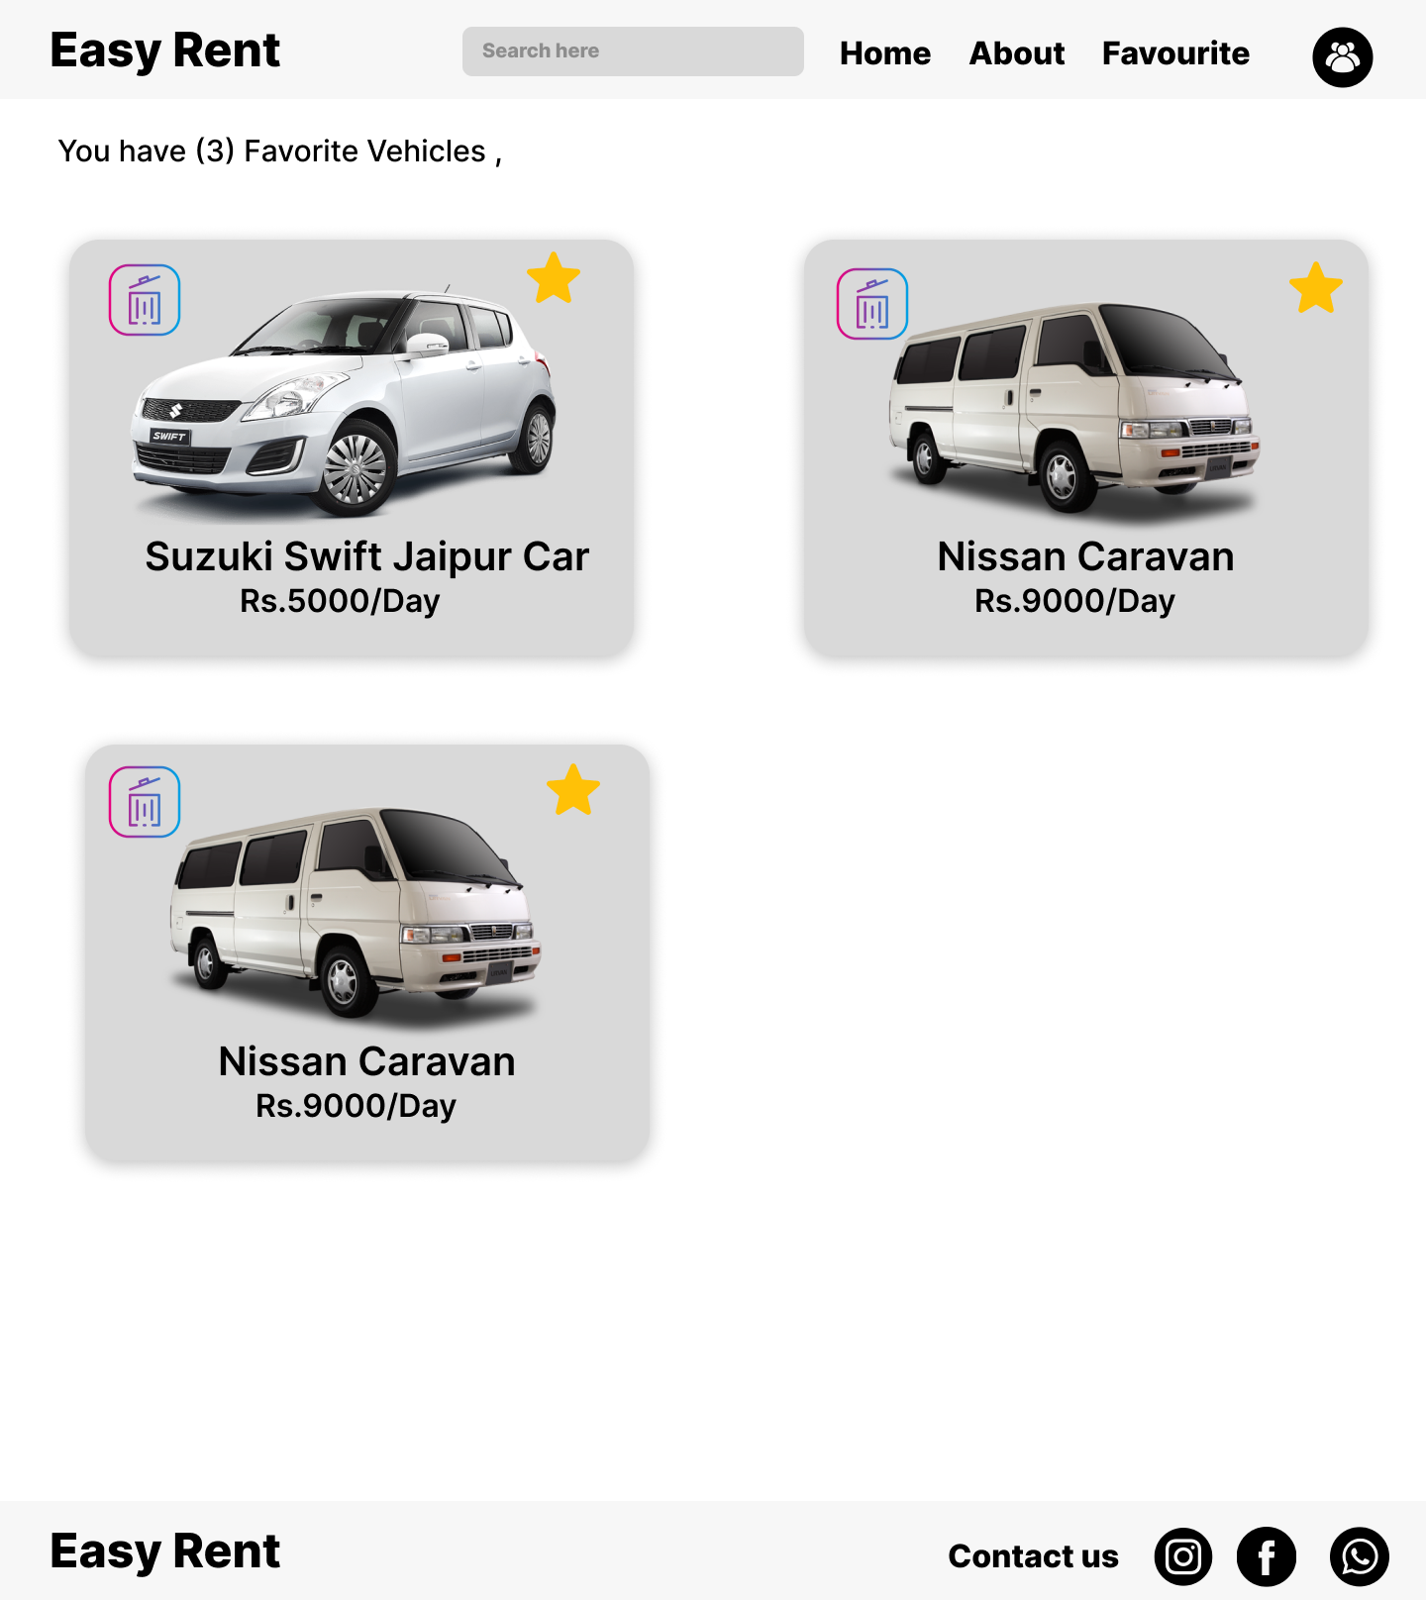

**Sequence Diagram**

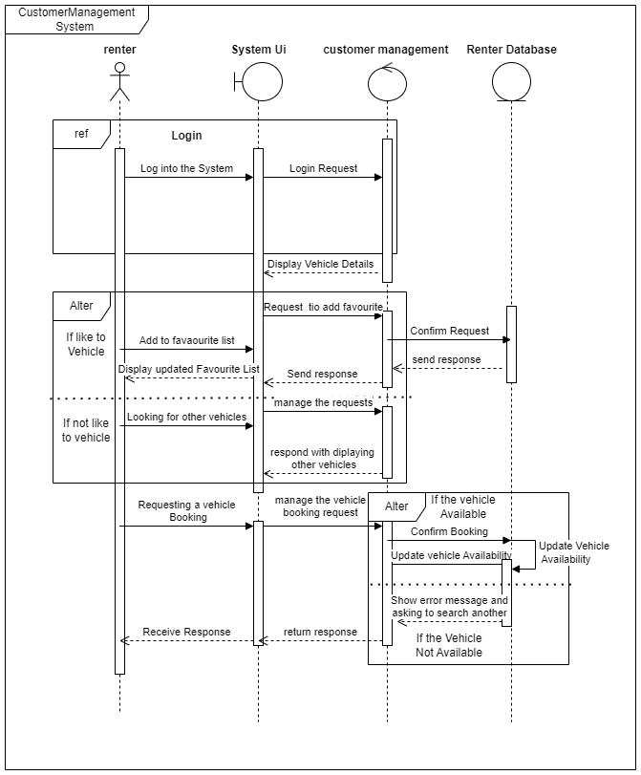

**Activity Diagram**

